When the the main page on Wikipedia is opened, we ca observe that an URL Request is made.

We can observe that the requests reach a specific IP address of the server and there an HTML page is being put together and send back to us have and the time response is 1.10s.

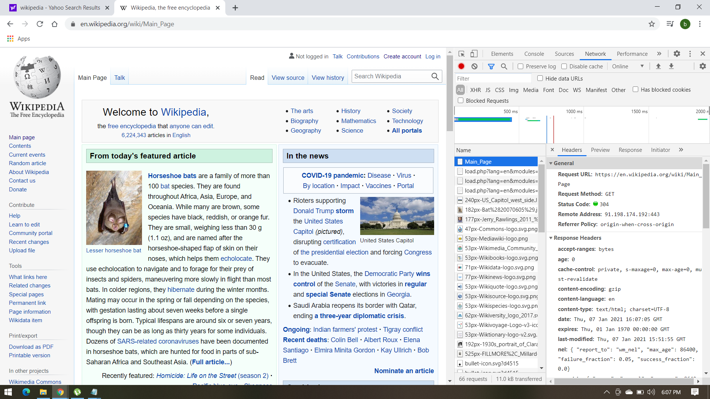

I observe that every time I load the main page, a different number of requests are made.

The page we get may request more elements, which are handled in the same manner, so this process is repeated as many times as it needs until the browser displays what we ask.

The Request Method is GET and we receive a Status code:304. This status code redirects us to a system of different files like png, jpg, gif, XML, CSS, etc

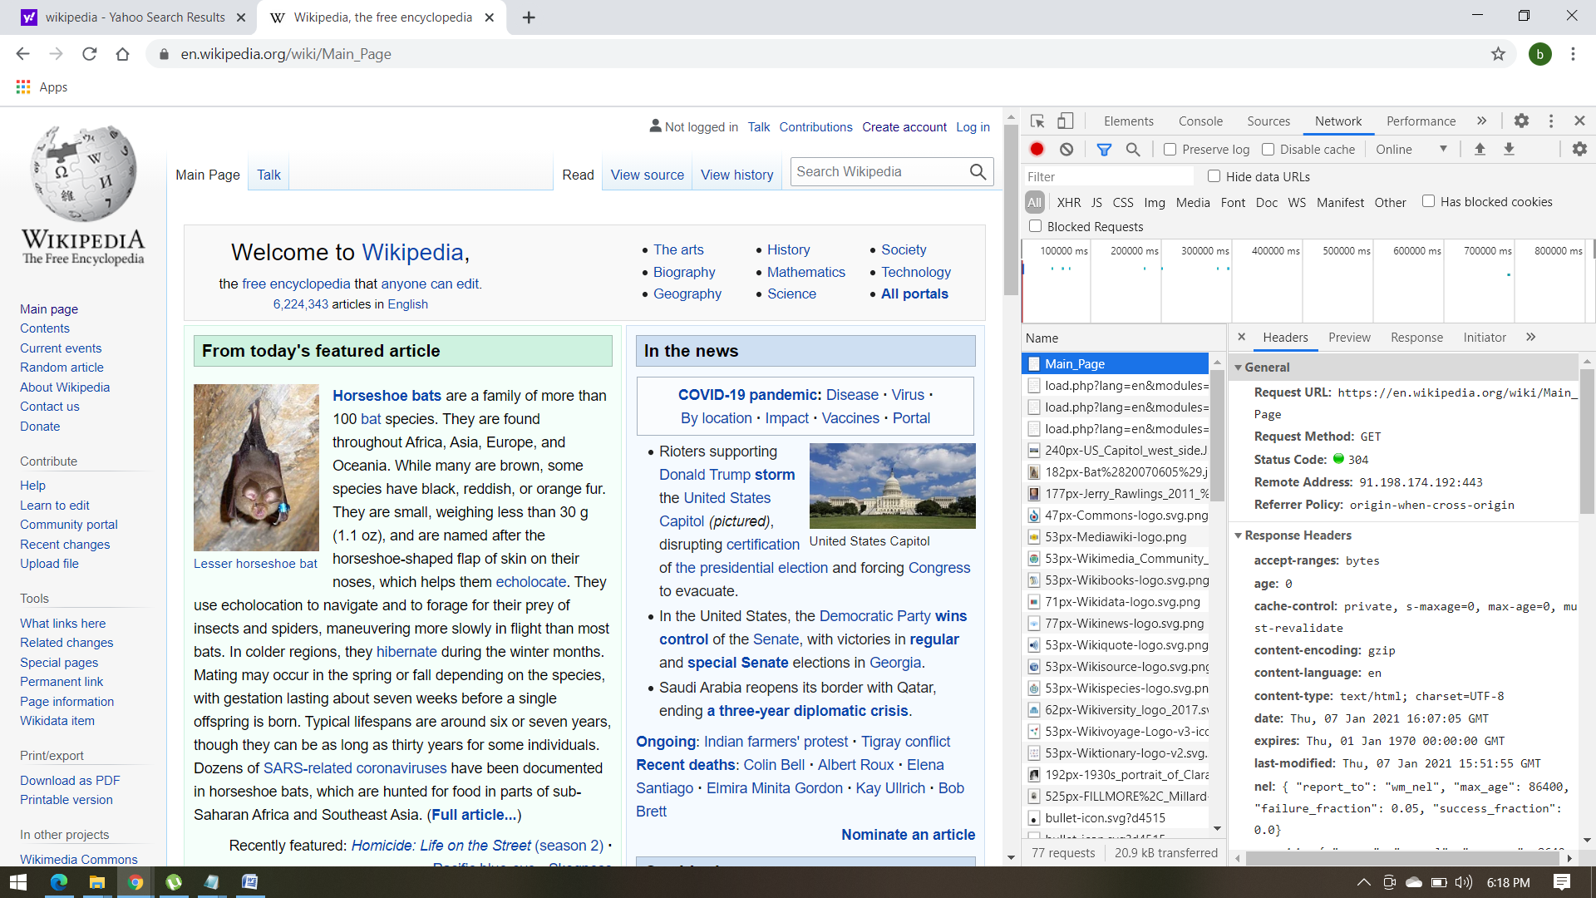

The Response Headers gives us accept ranges: bytes and we also receive as response an Html doctype.

We can also observe that cookies are stored and we receive many responses with status code 200 from the memory cache.

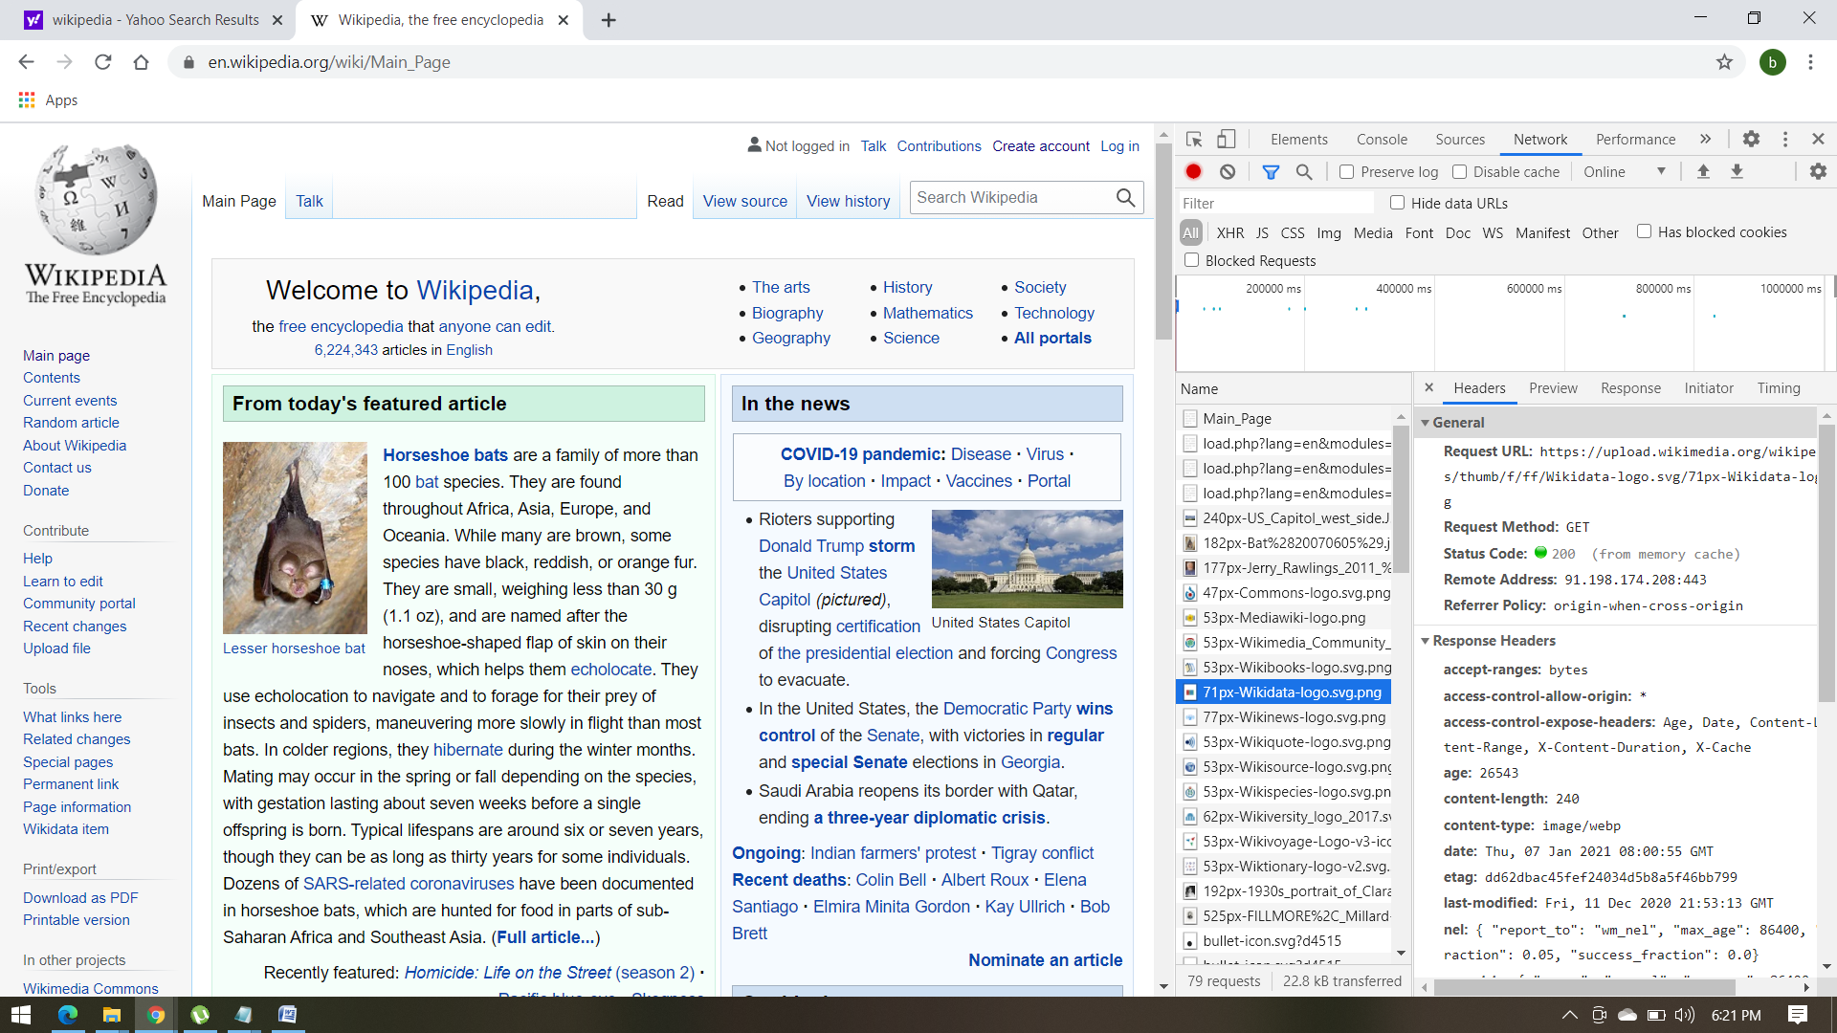

When we try to register a new username by providing invalid data in text fields we can see a POST Request Method.

Requests and Responses sent between the Web browser and the Web server and the responses are xhr files.

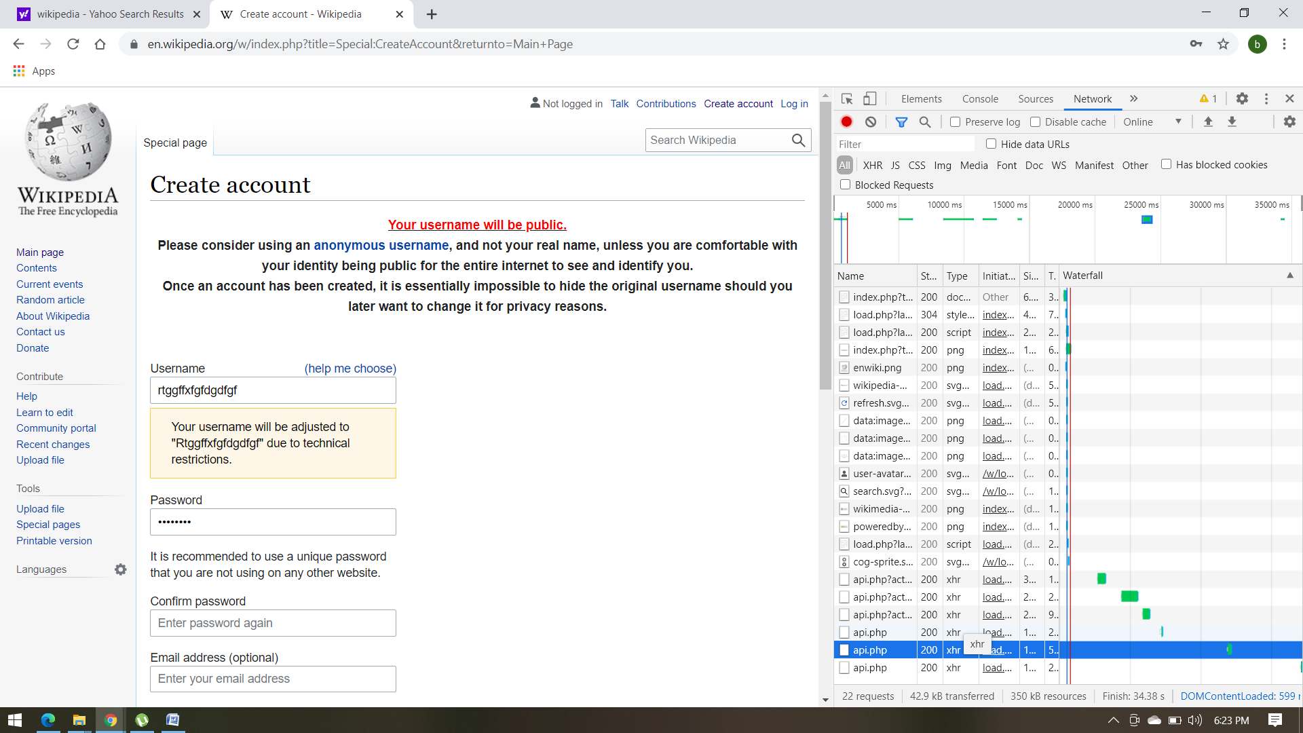

While we are typing the wrong data in text fields we cand observe multiple responses, all with Request Method: POST. We get Status Code 200 witch means that the action was successfully received.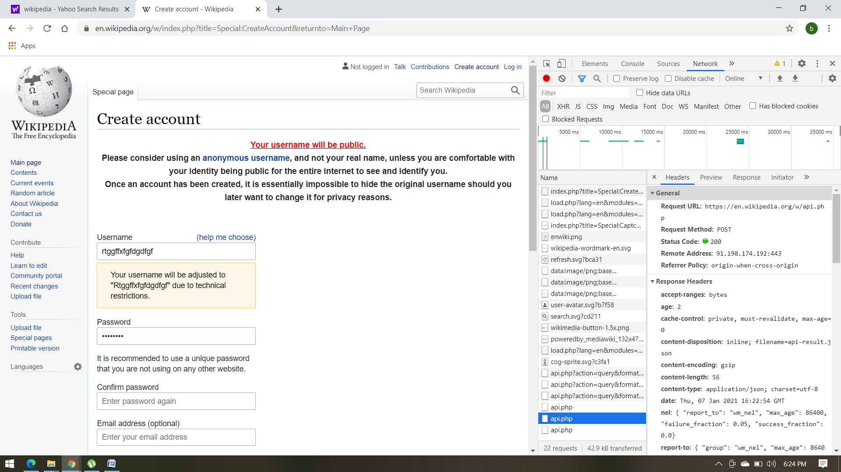

No additional cookies were added to memory storage.

When we provide valid data in the registration fields we can observe the following:

In headers, the first document has a Request method POST. By this, we get the confirmation that we send data to the server to create or update a resource.

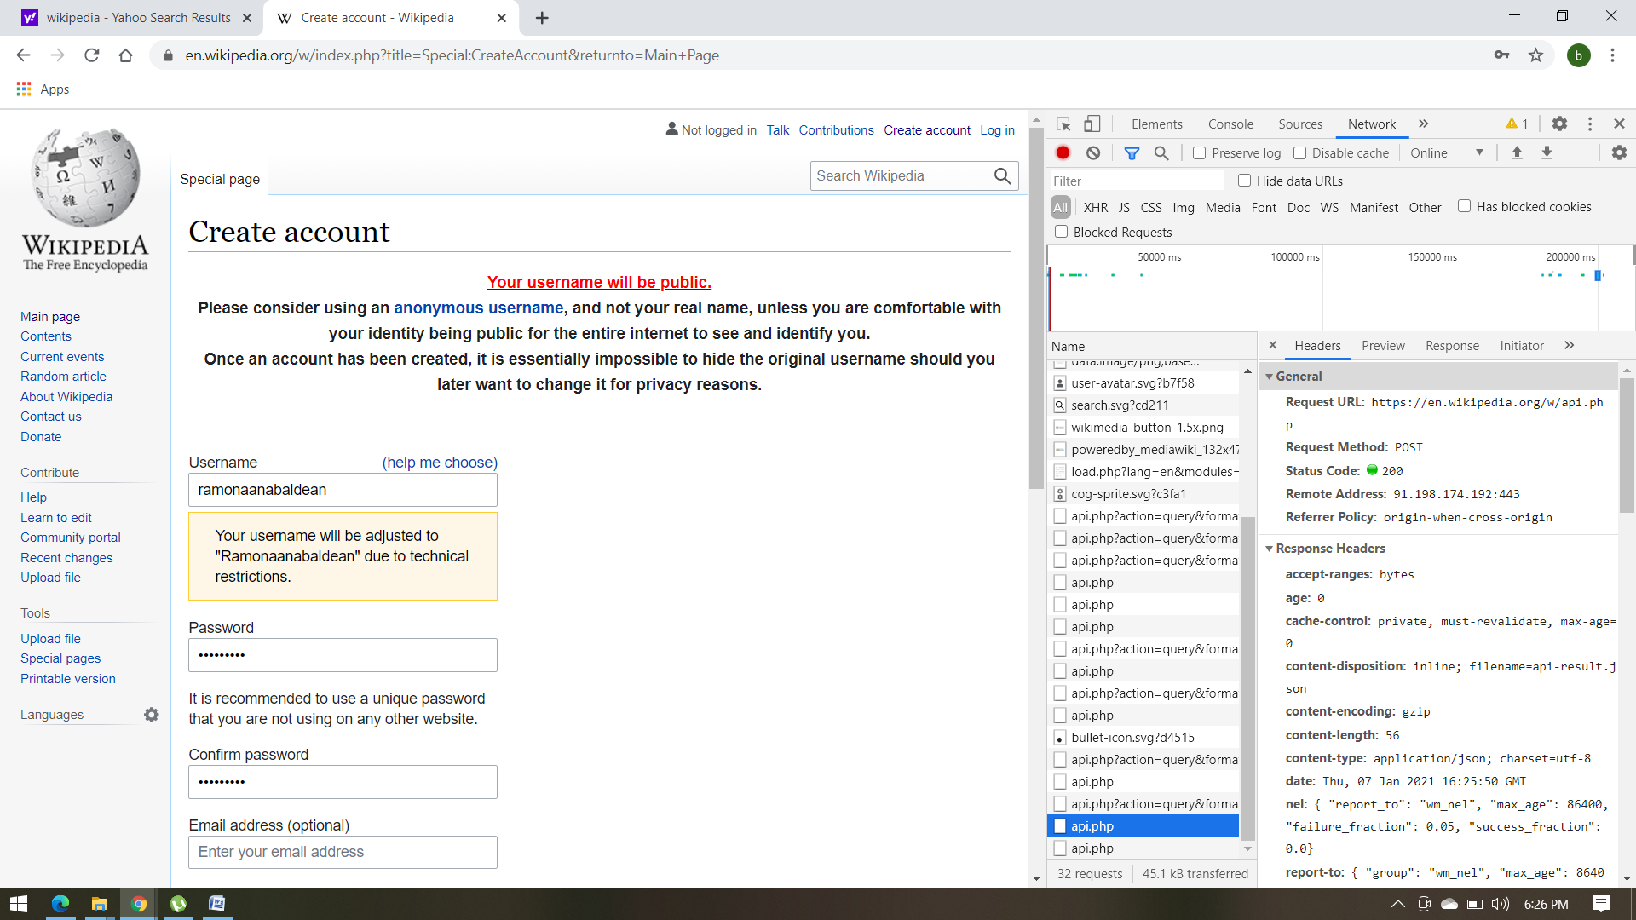

We can observe that the other response we receive are items that complete the page with different status codes like 302,304(redirection codes)

and 200,204(success codes) and all have Request Method: GET.

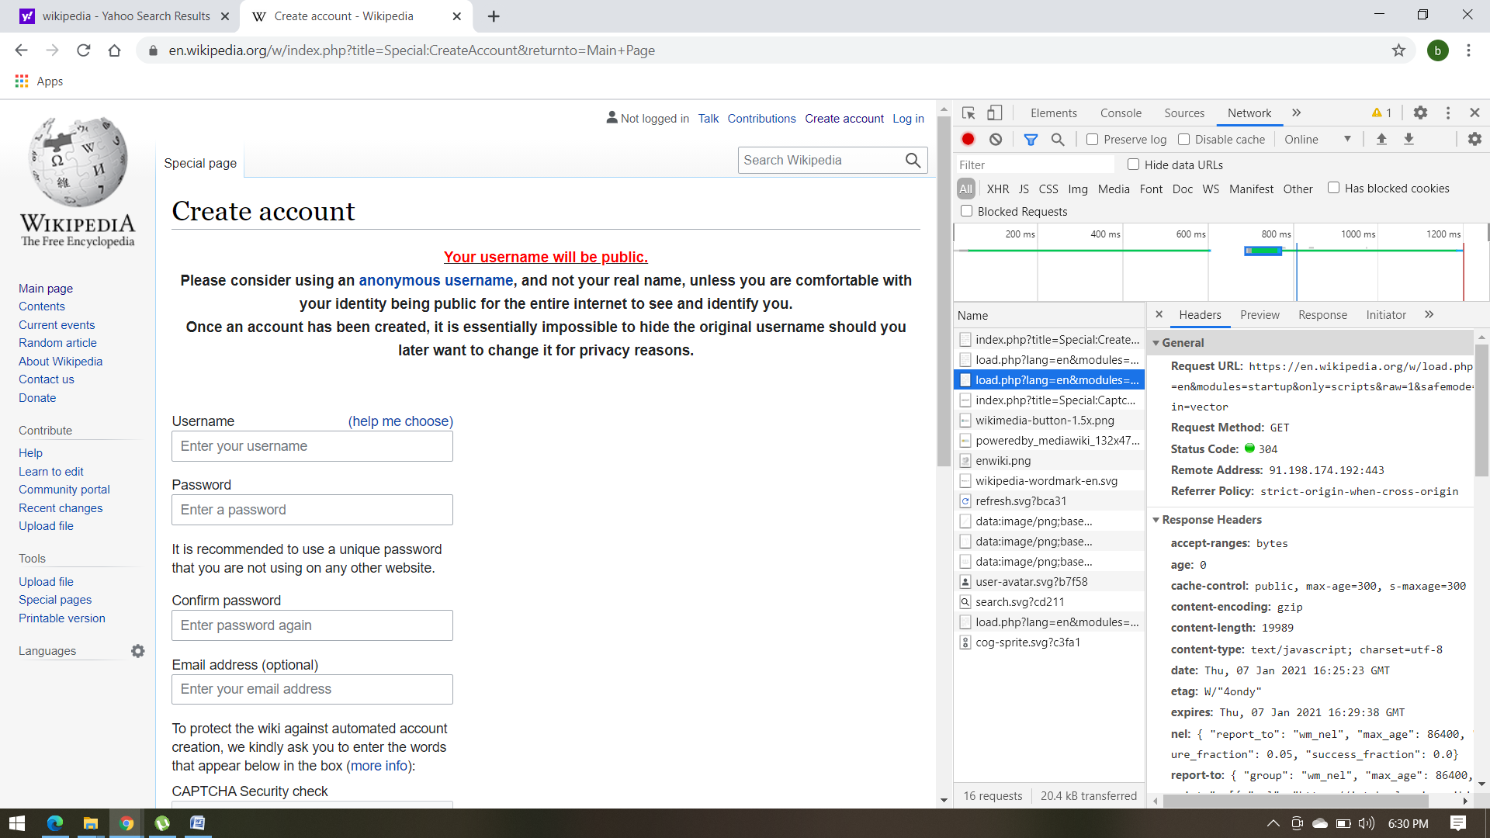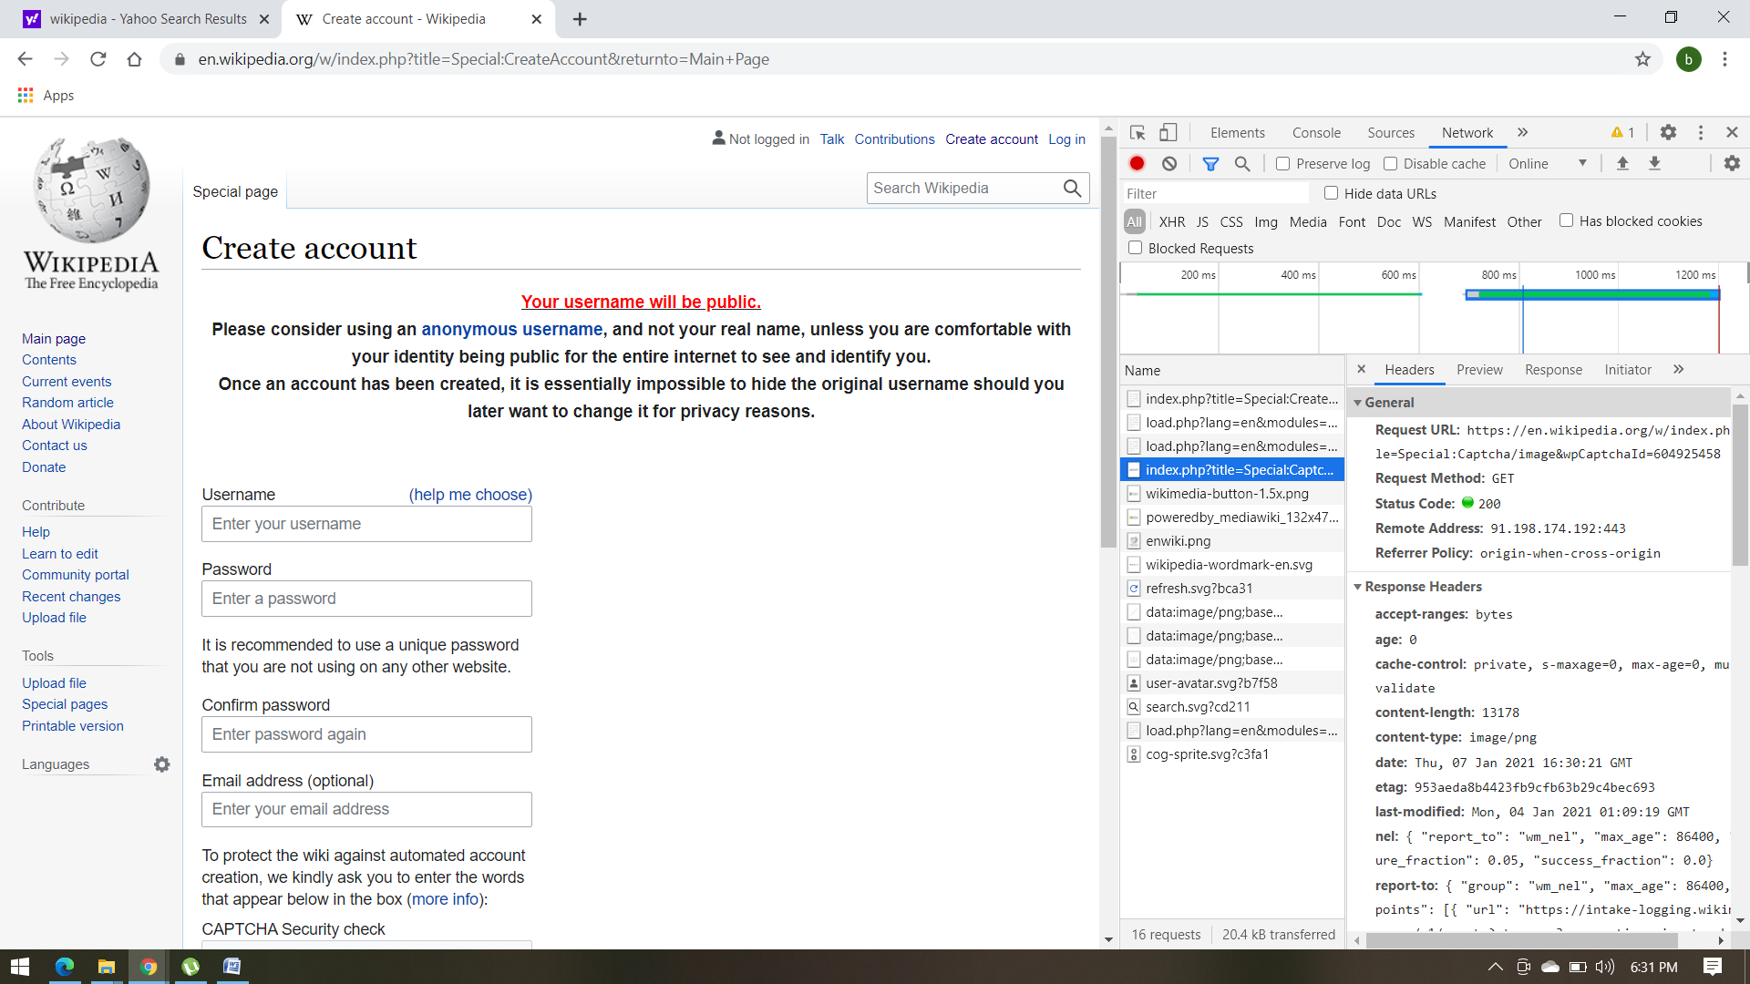

While tiping the valid data in text fields we can observe multiple responses in xhr type files.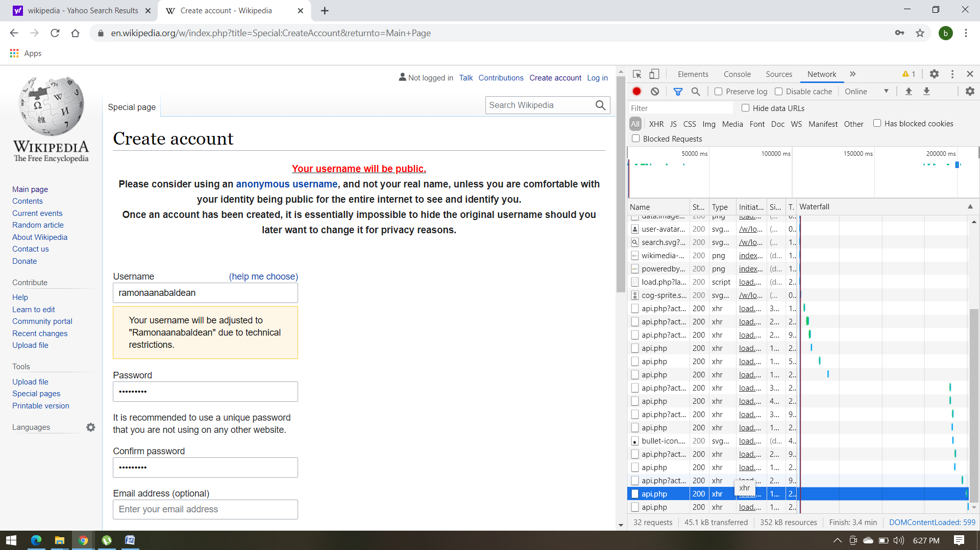

When we try to reset the password we can observe multiple requests with Request Method: POST and some with request Method: GET.

We can also observe that POST requests are not cached, and do not remain in browser history.